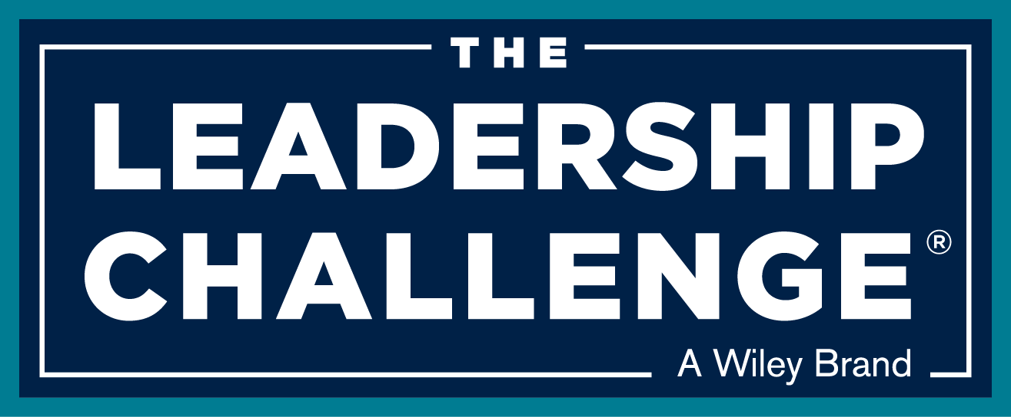

ELEMENTS TO USE IN WRITING A STORY
FOR THE LEADERSHIP CHALLENGE®

Recently we participated in a story-writing webinar led by Shane Meeker. Shane is the Procter & Gamble Company Historian & Corporate Storyteller. He collects and shares tales of the 177 year-old company, and he also teaches managers—not only at P&G but also at a wide range of other organizations—how to use story concepts, tools, and methods to coach teams and communicate key messages. Shane says that there are five ingredients to a rich story. They “Have a hero that you can relate to and understand, a conflict (or obstacle) that is powerful, treasures that are strong enough to motivate, a transformation that creates emotional resonance, and a powerful climax to resolve the story.” These five elements are universal in literature, film, television, stage plays, and tales you tell your kids.

We’ve adapted Shane’s framework a bit to fit the needs of The Leadership Challenge, and we think this template is a useful way of organizing our thoughts and recording the story. Here are some guidelines to use in writing your story:

- The Moral of the Story and the Practice. While you don’t write the moral until the end of a story, it’s important to remember that all the stories we include in The Leadership Challenge are intended to illustrate a practice, commitment, or behavior. They are intended to teach a lesson about exemplary leadership. Before you start writing, keep the “moral of the story” in mind. It gives direction to the narrative. For example, a moral or lesson might be: exemplary leaders do what they say they will do (MTW). Or, exemplary leaders can’t do it alone (EOA). Or, when there’s a mistake, treat it as a learning experience (CTP). You won’t reveal the lesson of the story until the end, but keep the lesson in mind as you write, It gives the narrative a direction. You can make better choices about what to write and not write knowing the point you want to make.

- Hero. Who is the hero of this story? [And, by the way, in this context hero has become accepted as a gender-neutral term.] In TLC stories the leader is going to be main hero, and we need to know a little about this person’s background, role in the organization. How did the leader get into this situation? (By the way, the hero is never the brand—e.g. The Leadership Challenge Workshop® or a company’s product or service. The brand is a mentor, not a hero. The hero is always a person. And, in our cases, a real person, not a fictitious one.)

- Cast. Who else plays a part in this story? Are there other central players that need to be mentioned? It might be the leader’s direct reports, peers, customers, manager, or family. They won’t get a whole lot of attention, but identify the other important players in the story.

- Context. Where does this take place? Provide some context for story. Paint the scene and set the stage for the reader so that they know where all the action happens.

- Obstacle. Shane Meeker says that the “Obstacle is the lifeblood of story.” Every story about every practice has something that comes along and creates problems for the leader and the organization. That challenge provides the dramatic tension. It’s the thing the leader is trying to change. And, as Shane points out, weak obstacles make for weak stories. There has to be something that really tests the leader in order to get the reader’s attention. What is the obstacle, challenge, problem, conflict, or adversity the leader is facing and has to overcome? In long stories—think The Lord of the Rings—there are usually many conflicts and obstacles to overcome. That’s what keeps us interested in watching for two or three hours. Something happens, and then something else happens, and then something else happens, and then, maybe, we get to a resolution.

- Treasure. What is the intrinsic or extrinsic reward (and there may be more than one) that motivates the leader to take on the challenge? What sustains the leader throughout? “Keep Your Eyes on the Prize” as they used to say during the civil rights movement. That’s what you do when you’re struggling through those obstacles. You keep your eyes on the prize. What exactly is that for this leader and organization in this story? Why are they really doing this? What do they hope to gain?

- Action. In the face of the obstacles and with the treasure in mind, the leader does things. What does the leader do that helps to resolve conflicts, break through obstacles, confront challenges, and overcome adversities? Keep in mind that we’re looking for actions that illustrate one or more of the behaviors. There’s a temptation here to say something like, “This leader modeled the way.” Or, this leader “Encouraged the heart.” Those phrases that we use as categories to describe a number of specific actions. Be really specific here about what the leader did. If there is one place that needs more detail, this is it.

- Transformation. There’s a point in the story when things change. Things are different than they were before. This is the before-and-after contrast. How was the leader and organization before, and how has the leader or organization changed since the beginning? Are people working more collaboratively? Is the leader being more consistent with espoused values? Are people feeling more engaged? What’s it like now in contrast with how it was before?

- Climax. What is the climax or conclusion? What is the powerful resolution of this story that creates emotion and memorability? What is the life-changing lesson learned? Did the leader or organization find the treasure or not? People may be feeling differently, but what has that achieved as a result? And then it’s back to that moral at the end of the story. As a result of taking action consistent with The Five Practices the leader’s behavior made a difference.

This is a lot to think about when writing a story, and you usually don’t have the space to include all the detail. Still, these elements can guide you in gathering together all the information you’ll need to write a memorable story.

Now that you’ve got all the elements, it’s time to write the story!

To help you get started, we’ve created a worksheet where you can jot down some notes. Give it a try and see if you can write a story.

